John Funk
John@funkearlychildhood.com
385-414-1239
Simple Mad Scientist

Common Early Childhood Science Standards
- Identifies five senses (including body parts) and uses them to make observations
- Begins to use scientific practice words, such as observe, describe, compare, predict, question, etc.
- Categorizes and sorts observable phenomena into groups based on attributes (color, size, texture, etc.)
- Investigating living and non-living things.
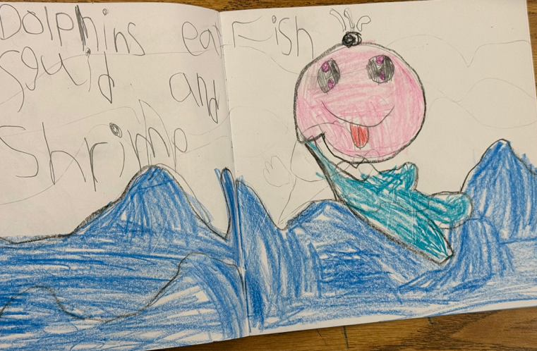
- Describe changes in day and night.
- Describe changes in weather over time.
- Experiments with magnets.
- Life Cycles

What Preschool Children Learn:
- Physical properties
- Classification
- Gravity and magnetism
- Cause and effect
- Life cycles
- Observations

Classroom-friendly Science
- Keep in mind how to inspire children’s curiosity.
- Hug ‘WOW’ experiments are often lost on children who would prefer to just play in the goop.
- Plan experiments using materials that are in the classroom or easily accessible. (Often teachers postpone hands-on activities because they don’t have time or resources to gather the materials.)

- Teach Children Observation
- Scribble Chase
- Observation field trip (emphasis on the environment or world)

- Rain Cloud in a Jar
- Fill your plastic jar with water to about ¾ full
- Spray the non-gel shaving cream in the jar until it forms a cloud
- Let your child use a dropper to add a few drops of food coloring to the cloud
- As they continue to add the drops, the food coloring will seep down into the water leading to a rain-like effect

- Items that Melt in the Sun
(suggestions)
- A marble
- A cube of cheese
- Ice cubes
- A Lego
- Butter
- crayons
- A small piece of bar soap
- A square of chocolate
- A coin

- Magnetic Fun
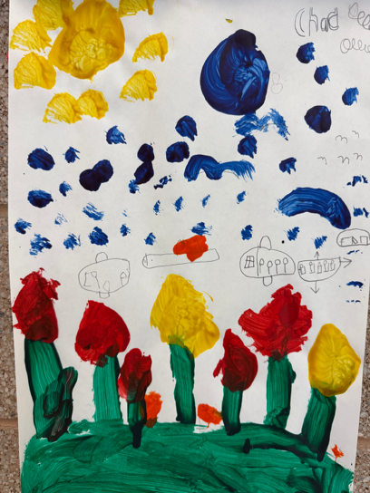
- Tray
Magnetic marble
- Magnet Wand
- Tempera paint

- Lemon Volcano
- Lemons
- Food coloring
- Dish soap
- Baking soda

- Grow a Rainbow
- Paper towel
- Markers
- 2 cups of water (food coloring will also work)

- Magic Dancing Rice or Raisins
- Water
- Vinegar
- Baking Soda
- Rice
- Food coloring (optional)

- Strong Shapes
- Sturdy Pape
- Tape
- Items of various weights

- Sink or Float Variation
- Water tub
- Craft sticks
- White glue
- Items to ride the raft

- Growing From the End Result
- Pumpkin seeds (or other vegetable retained from earlier excavation)
- Potting soil
- Small containers
- Water

