Children’s Literature Books 5/19

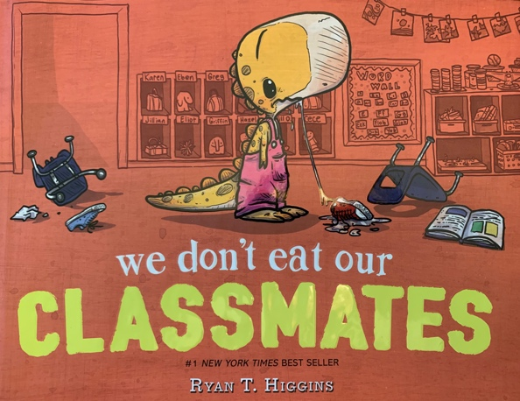
We Don’t Eat Our Classmates by Ryan Higgins
Moo by David LaRochelle
Square by Mac Barnett
Triangle by Mac Barnett
Circle by Mac Barnett
Guess Again by Mac Barnett
Julian is a Mermaid by Jessica Love
Alma and How She Got Her Name by Juana Martinez-Neal
Saffron Ice Cream by Rashin Kheiriyeh
Thank You, Omu by Oge Mora
A Big Mooncake for Little Star by Grace Lin
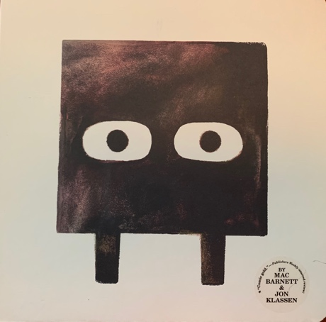
Home is a Window by Stephanie Ledyard
The Funeral by Matt James
How to Babysit a Grandpa by Jean Reagan
Tell Me a Tattoo Story Alison McGhee
The Rough Patch Brian Lies
Hey, Water! By Antoinette Portis
How to Two by David Soman
Count the Monkeys by Mac Barnett
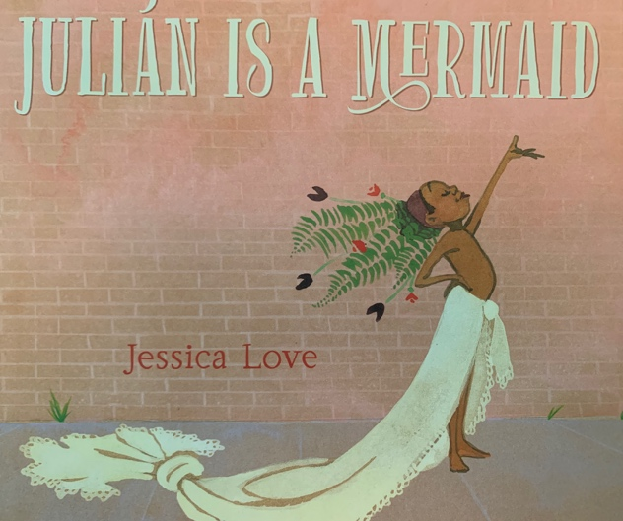
Rhyme Flies by Antonia Pesenti
Thank you, Earth by April Pulley Sayre
The Ugly 5 by Julia Donaldson
Red by Jed Alexander
There’s a Dinosaur on the 13th Floor by Wade Bradford
Hello, Lighthouse! Sophie Blackall
Big Umbrella by Amy June & Jupiter Bates

