John Funk
Targeted Social and Emotional Support
(Social Emotional Teaching Strategies)
Intensive Intervention
www.funkearlychildhoodconsulting.com
john@funkearlychildhood.com

High Quality Supportive Environments
(Designing Supportive Environments)

Nurturing Responsive Relationships
(Building Positive Relationships)

CSEFEL – www.csefel.vanderbilt.edu

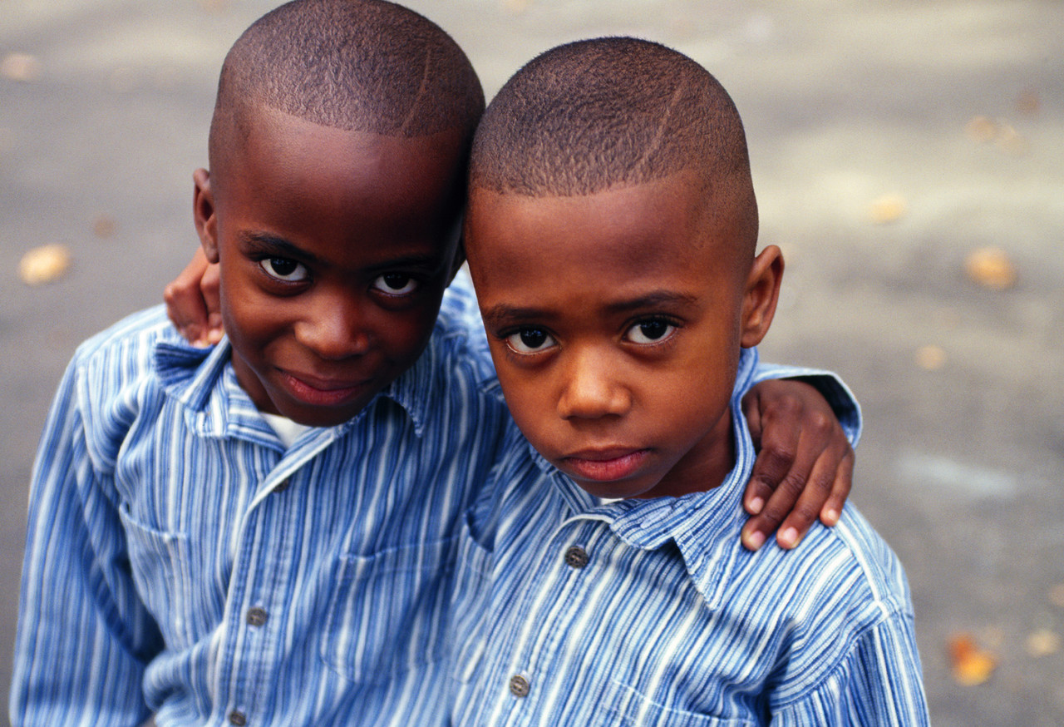
Building Positive Relationships

- Administrative support of positive relationships.
- Monitoring positive/negative ratio.
- Monitor and encourage positive teacher attitudes.
- Begin before school

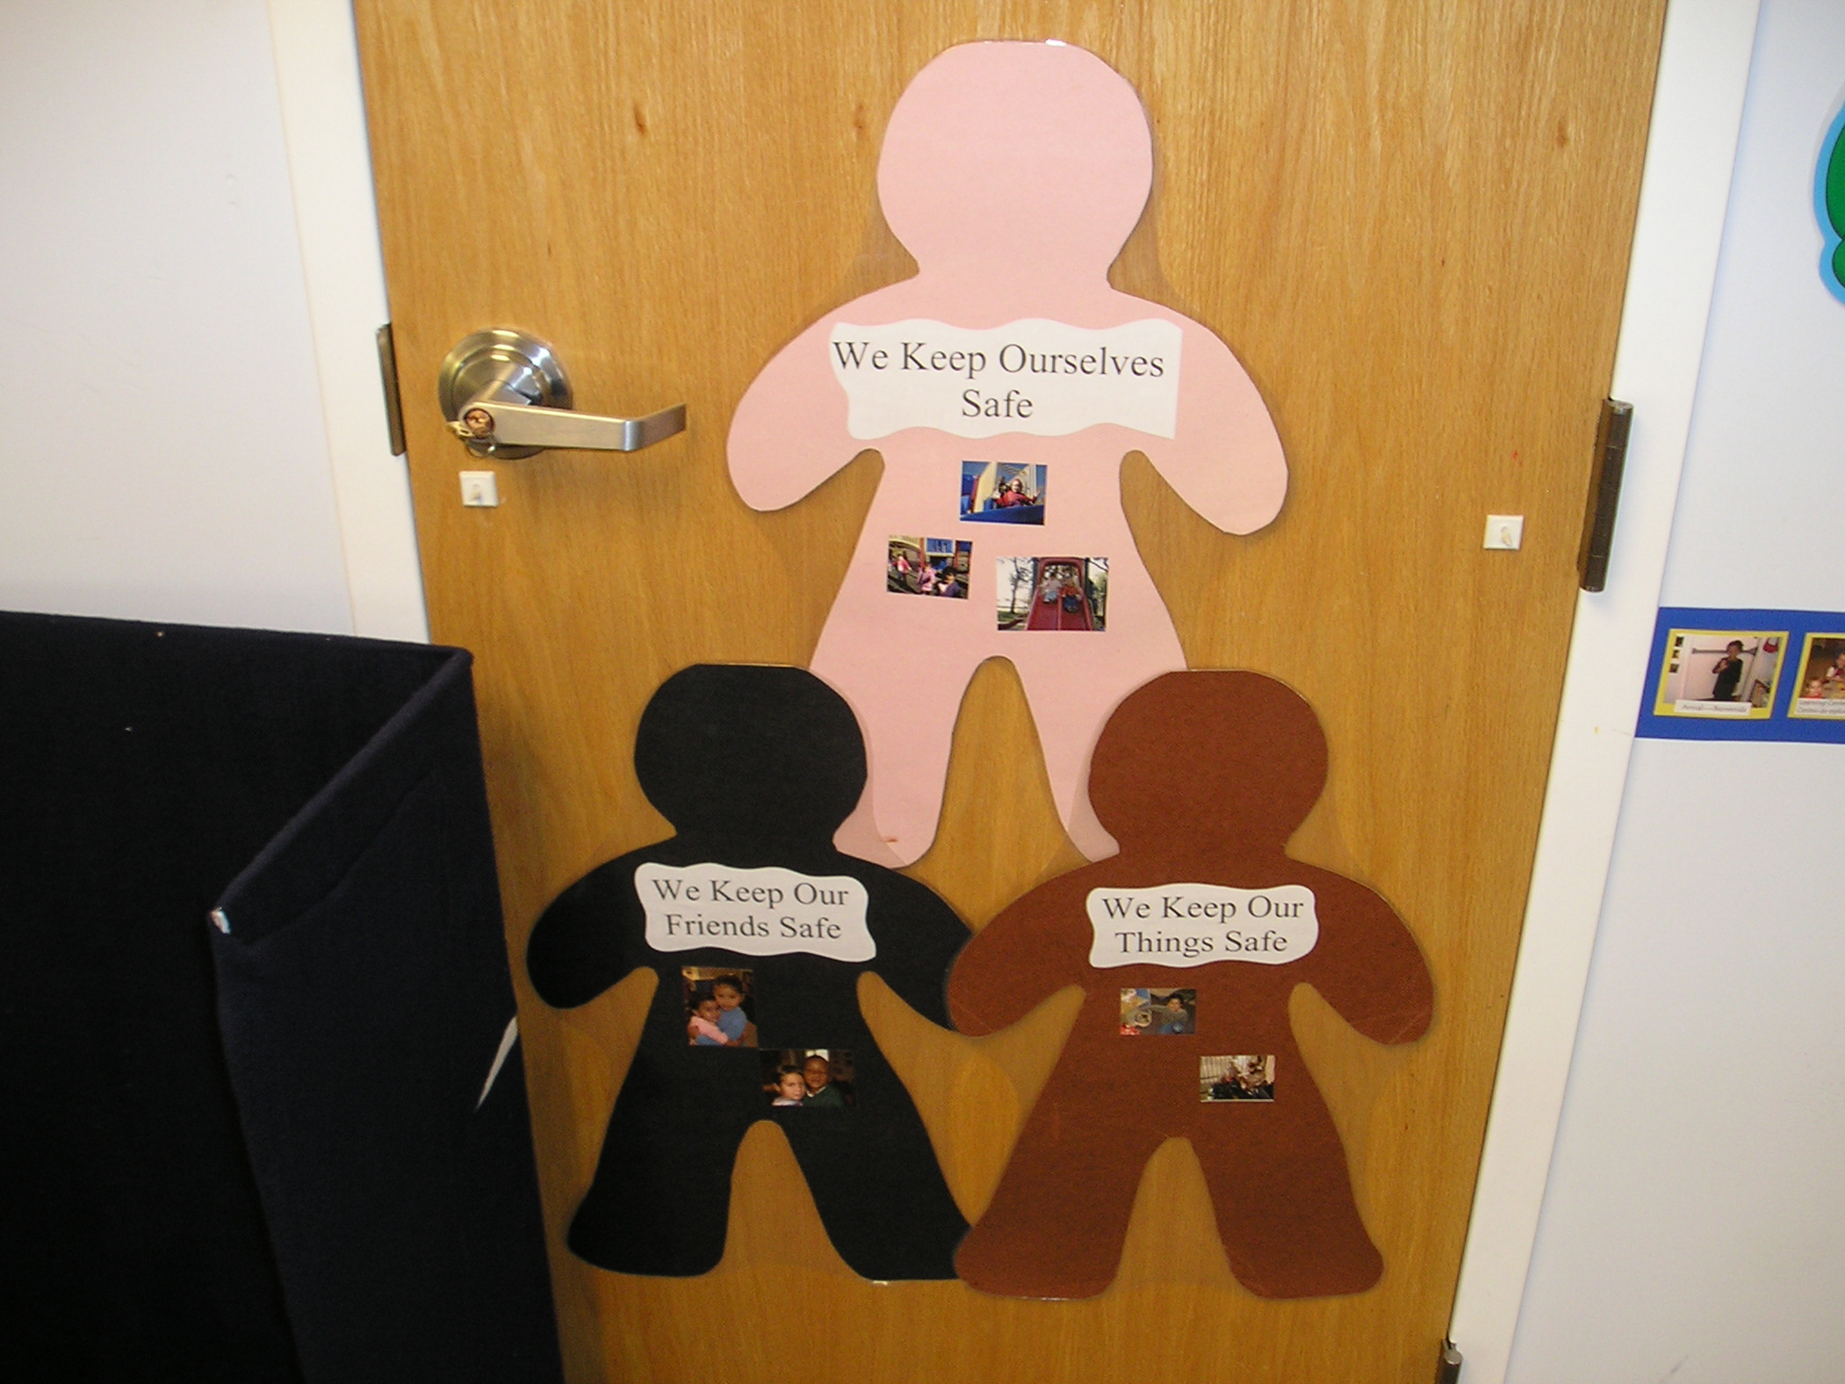

Designing Supportive Environments

- Comfortable classrooms.
- Supportive routines (including arrival).
- Visual schedules of events and centers.
- Visual rules and procedures.

Social and Emotional Teaching Strategies

- Concrete social and emotional lessons (friendship skills)
- Incorporating social and emotional strategies into every day procedures and schedules.
- Continual modeling of social emotional skills.

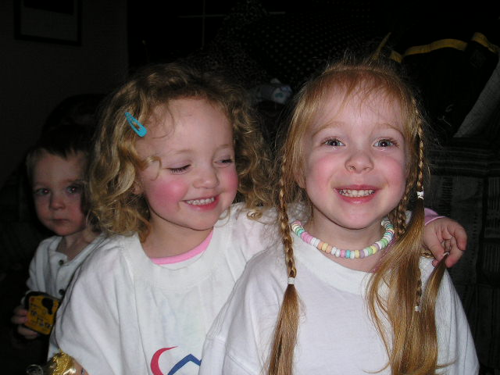

Individualized Intensive Interventions

    - Providing support for learning interventions skills or intervention support personnel.

Other Considerations:

- Solid, dependable routines are the security blanket of the classroom. Children should always know what to expect.
- When you pre-teach routines, expectations, and rules, you will be able to keep emotions in check and create teaching moments.
- Having a planned signal can keep you in control while allow the children more control.

