Developmentally Appropriate Math Sequences (PreK-K)
John Funk, University of Utah, Funk Early Childhood Consulting
john@funkearlychildhood.com www.funkearlychildhoodconsulting.com

1: Can Explore with Materials

Observing the colors, shapes, sizes, textures and other attributes of materials, as well as recognizing the naming the properties of discrete and continuous materials. Discrete materials are those that can be counting, such as blocks or cookies. Continuous materials are those that can be measured, such as water or sand.

2: Recognizes Spatial Relationships

Distinguishing objects by telling where they are in the space with knowledge of direction and position. “Do you mean the one in front or the one in back?”

3: Classifies and Sorts by Attributes

Sorting and grouping objects based on the likenesses and differences of attributes.

4: Creates Patterns by Extending and Comparing

Recognizing, copying, extending and creating the repetition of specific items.

5: Shows One-to One Correspondence and Recognizes the Manyness of Sets

Understanding one-to-one relationships while counting items. Matching objects to determine the size of a set (greater than, less than, equal to, etc.).

6: Understanding Ordering

Organizing materials and information in a specific order based on relationship. Order implies specific patterns (such as, the number s 0-9 or days of the week). Sequence implies what comes next.

7: Demonstrates Understanding and Recognition of Numerals 0-9

Understanding the “manyness” of a number and assigning a numeral (symbolic representation) to that number. Understanding that the symbol “5” means five objects. **Do not confuse with the ability to rote count.

8: Recognizes and Manipulates Basic Shapes

Recognizing geometric figures and their attributes (a child should have thorough knowledge of numeration prior to being asked to identify attributes, such as, “How many sides to this shape?”).

9: Understands the Concept of Measurement

10-12 Place Value; Fraction; Time and Money

Material Suggestions for Beginning Messy Math
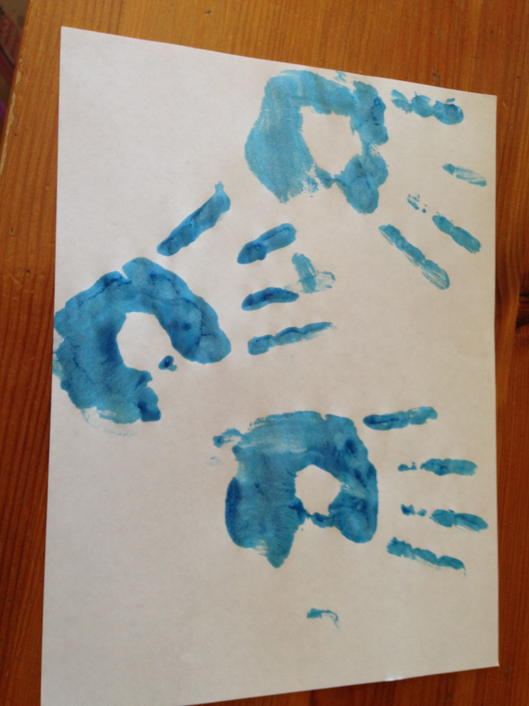
- Paint
- Finger painting
- Painting with a brush
- Painting with instruments
- Zip lock bag sensory slate
- Liquid watercolor spraying
- Watercolors
- Putty

- Sensory Bin
- Insta-snow
- Sand
- Water
- Manipulatives
- Corn starch colloid
- Flour, masa, macroni, etc. (where good items are allowed for exploration)
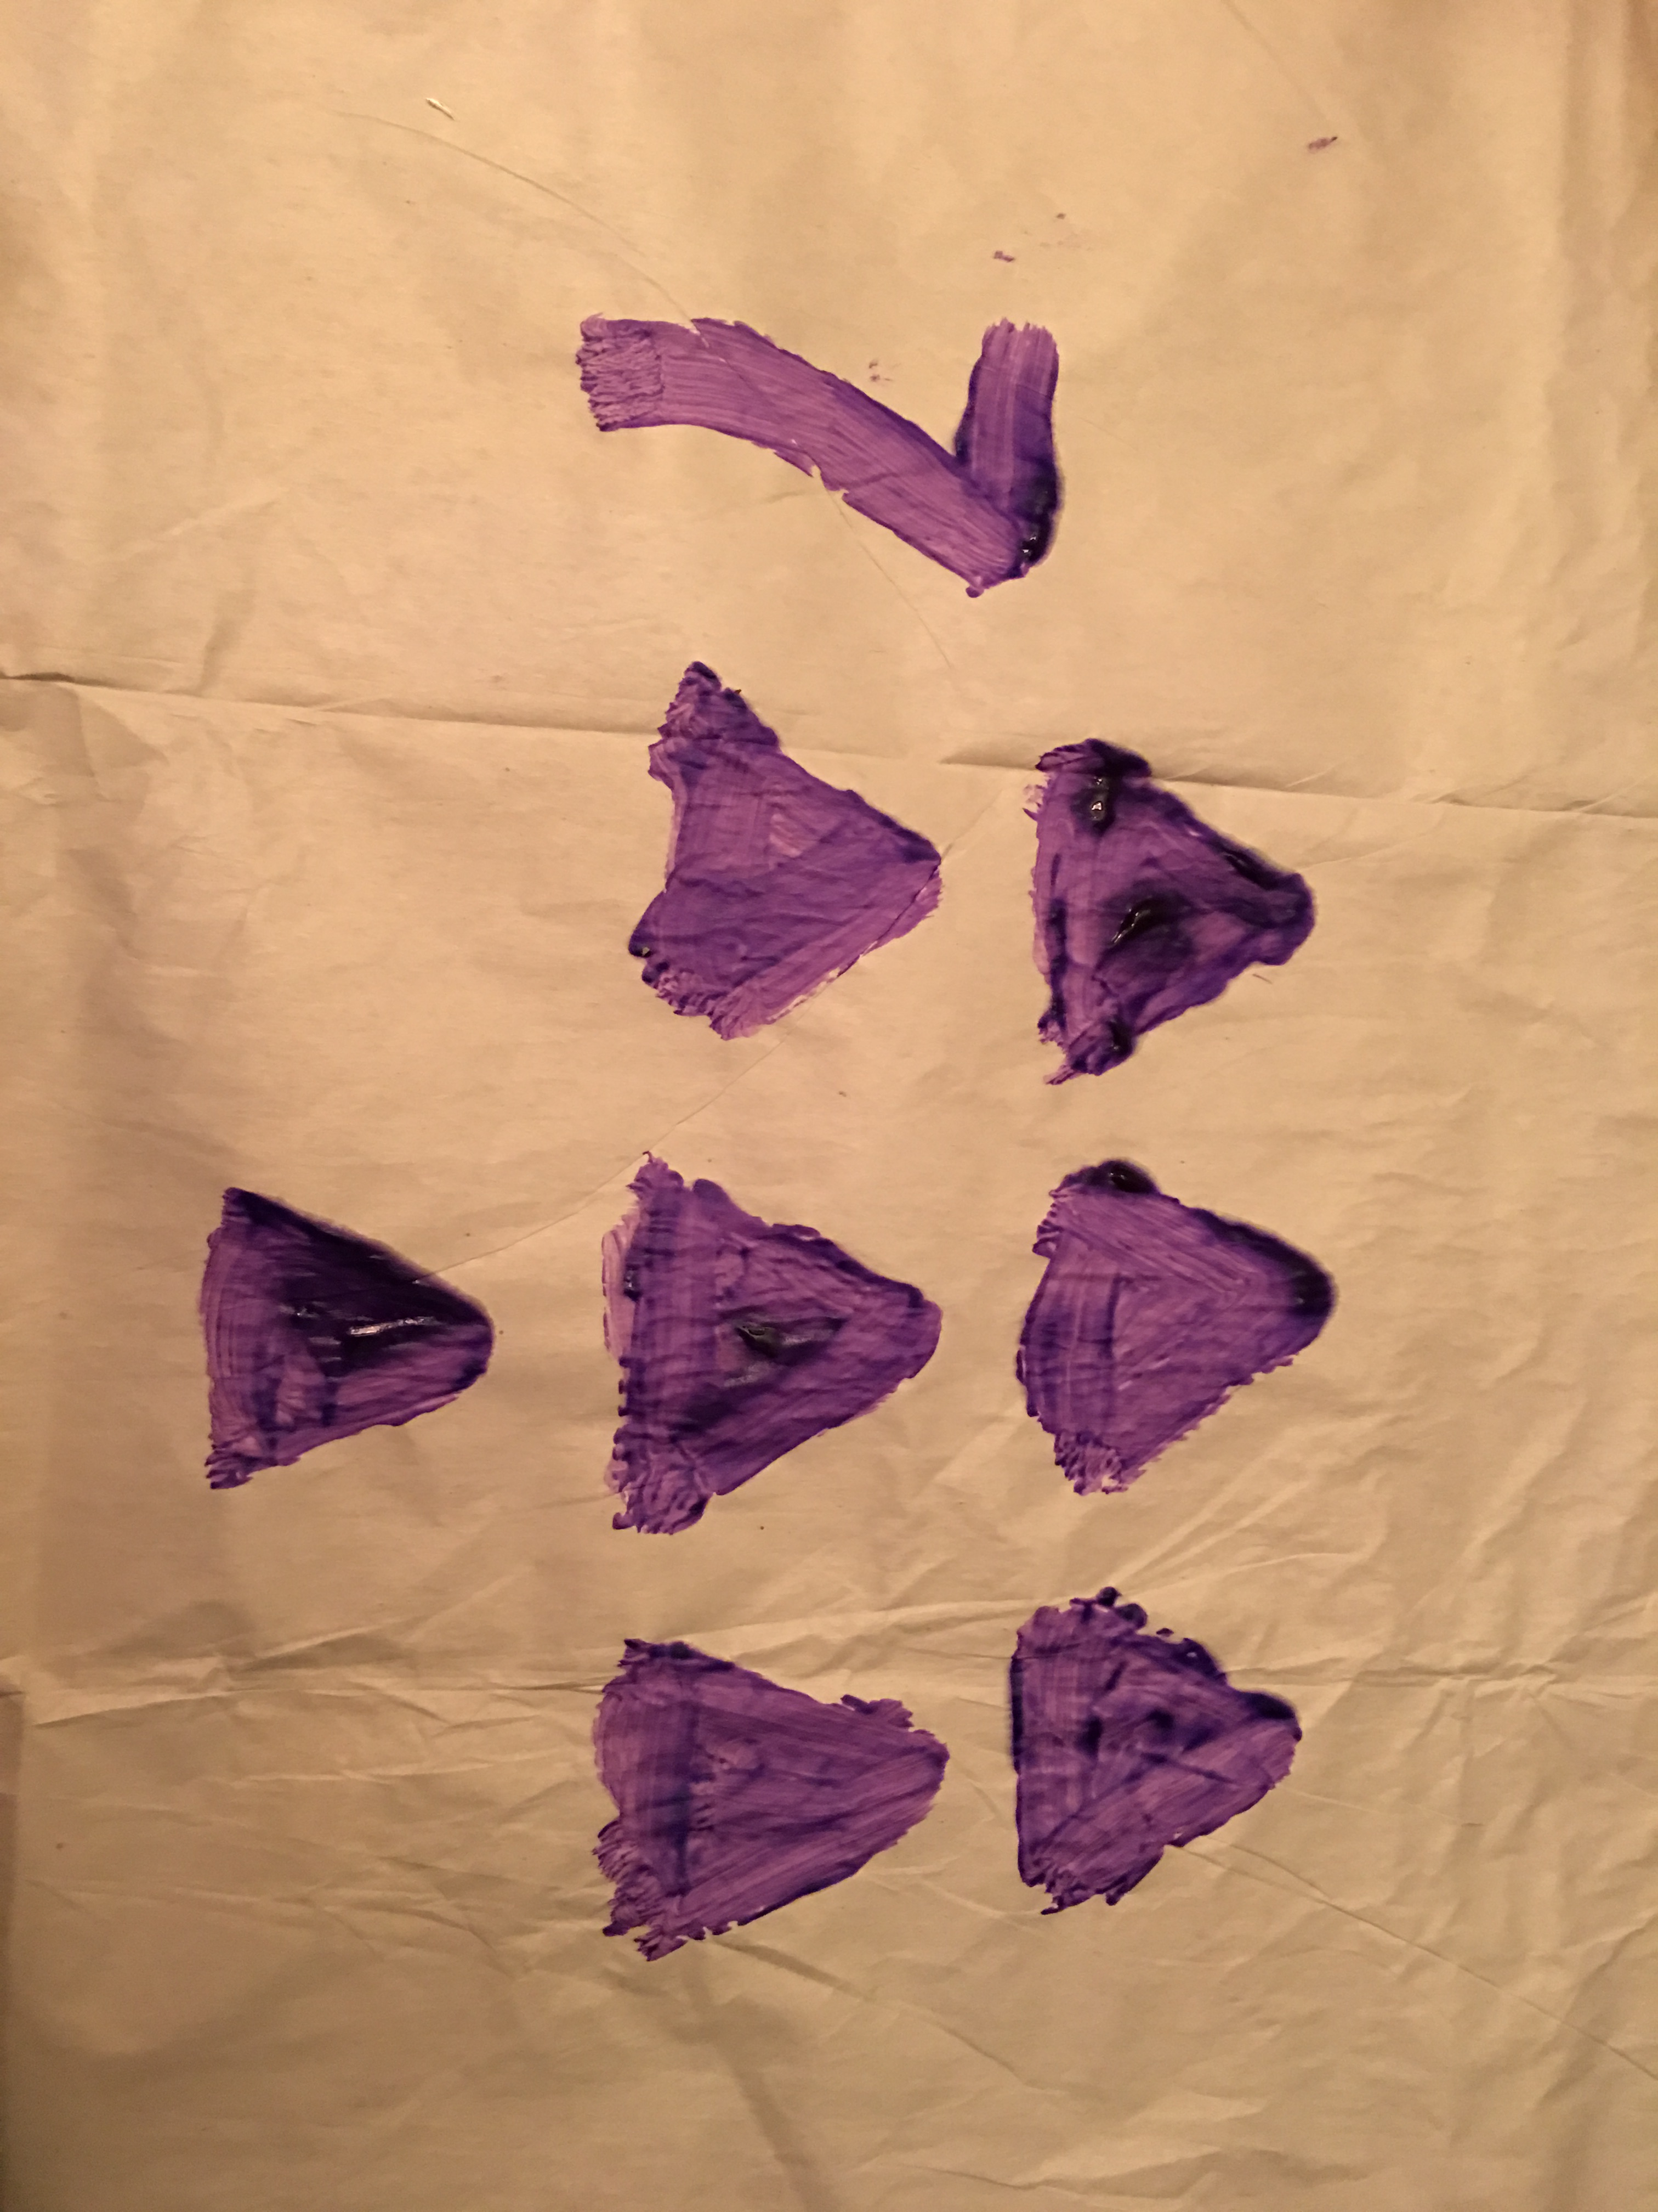
- Crayons/Markers
- Drawing
- Writing
- Counting
- Classification
- Measuring

