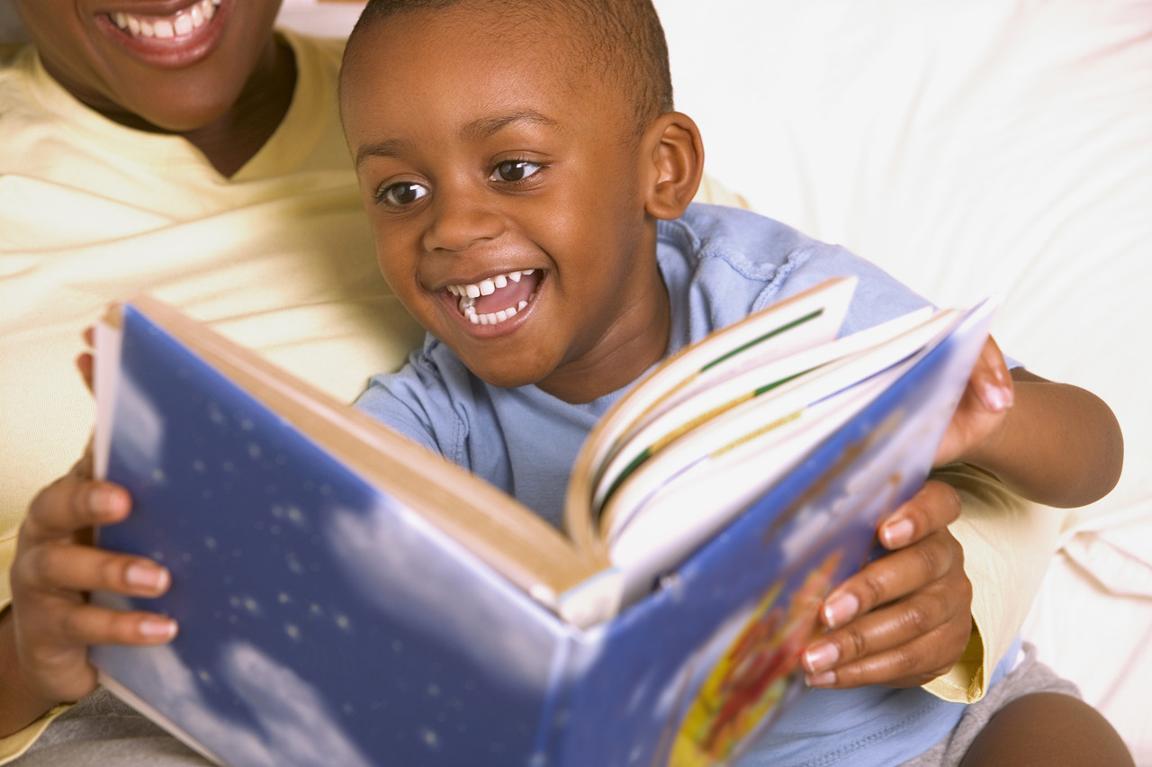
Language & Literacy
with a STEM Focus

John Funk, john.funk@utah.edu
www.funkearlychildhoodconsulting.com

Components of Highly Effective Classrooms
- All science/math/engineering instruction integrated with reading and writing
- Every minute of time used well-even mundane routines are instructional
- Provide scaffolding
- Emphasis on self-regulation and self-monitoring
- Abundance of reading and writing in other content areas
- Teachers have high expectations for all children
- Teachers have excellent classroom management procedures

STEM Focuses
- Classifying/Sorting
- Observation
- Construction
- Spatial Relationships
- Ordering
- Patterns

Language and Literacy Ideas

Phonemic/Phonological Awareness:

- Constructing a model of a portion or object in a nursery rhyme (ex: Miss Muffett’s tuffet or bowl or curds and whey) is a great engineering exercise.
- Recreate nursery rhyme using materials and figures. Recite nursery rhyme using props helps with sequencing.
- Hide rhyming word animal pictures in dry sand. Find the matching pictures. Add another science element by putting a magnetic strip on the pictures.
- Build 2-3 items that begin with the same sound (ex: boy, ball, bat).
- Discuss the sounds that animals make.
- After building a pretend habitat out of materials, identify the beginning sound of the item(s).

Letter Recognition:

- Hide letters of the alphabet in sand. Name each letter when it is found (looking for attributes that are the same and different is essential for math and science).
- Hide magnetic letters in sand and find the letters using a magnetic wand.
- Form letters of the alphabet out of wet sand-fill letters with water.
- Match letters of the alphabet to different foods that are healthy.
- Use alphabet cookie cutters with playdough or gak.
- Make a science journal and have the children indicate which alphabet letters are used in the science words.
- Float foam letters in water, fish them out with tongs or ladle and name them.
- Float magnetic letters in water and using a magnet attached to a string, fish out the letters and name them.
- Float letters in water and using a ladle, fish out two letters that are next to each other in the alphabet.
- Do a letter recognition activity with translucent letters and the light table.
- Recreate letters in the environment using molding materials.
- Do a classification and sorting activity with letter so the alphabet.

Print Awareness:

- Use science-based books for reading and comprehension discussions.
- Share more information about the scientific subject of the books shared.
- Take the child to the library and have him/her find books about a certain animal, weather, seasons, etc.

Listening Comprehension:
- Instead of asking questions, respond to a story by creating a favorite part of the story with wet sand or playdough.
- Create three parts of a story that indicate numbers, such as the 3 Pigs, to support mathematics skills.
- With a partner, construct a story just read and use the project to retell the story to others.
- Create your own story, using pictures, about an animal and it’s habitat.
- Create an additional part of a story using materials in the sand/water table.

Writing:

- ‘Fish’ for a magnetic letter of the alphabet. Practice writing that letter.
- Draw a picture of your favorite food.
- Create a self-portrait (with body parts) using play dough or construction paper..
- Smell a new smell for your five senses. Draw a picture of what you think created the smell.
- Create a journal about some mathematical concept, such as classifying, sorting, counting, or shapes.

Oral Language:

- Explain the creation made in the sand table or play dough tray (creations could be a science or math concept)
- Explain the process that happens in the pouring center with water, snow or ice.

